
School of Tech
Bachelor of Business Information Management
Cover Sheet and Student Declaration
Course Title: | BBIM502 Introduction to Programming | Course code: | BBIM502
Student Name: |  | Student ID:
Assessment No & Type: | Assessment 2  Project | Cohort:
Due Date: |  | Date Submitted:
Tutor’s Name:
Assessment  Weighting | 60%
Total Marks | 100

Student Declaration:
I declare that:
- I have read the New Zealand School of Education Ltd policies and regulations on assessments and understand what plagiarism is.
- I am aware of the penalties for cheating and plagiarism as laid down by the New Zealand School of Education Ltd.
- This is an original assessment and is entirely my own work.
- Where I have quoted or made use of the ideas of other writers, I have acknowledged the source. • This assessment has been prepared exclusively for this course and has not been or will not be submitted as assessed work in any other course.
- It has been explained to me that this assessment may be used by NZSE Ltd, for internal and/or external moderation.
- If I am late in handing in this assessment without prior approval (see student regulations in handbook), marks will be deducted, to a maximum of 50%.
Student signature:
Date:

Tutor only to complete
Assessment result: | Mark /100 | Grade
LO2 Requirements | - Met  - Not Met | Assessor Signature
LO3 Requirements | - Met  - Not Met | Assessor Signature
LO4 Requirements | - Met  - Not Met | Assessor Signature

LANGHAM HOTEL MANAGEMENT SYSTEM (LHMS) - PYTHON IMPLEMENTATION REPORT

TABLE OF CONTENTS
1. Introduction and Purpose 4
2. System Overview 5
3. Pseudocode 5
4. Implementation Details 8
4.1 Menu Operations 8
4.2 File IO Operations 9
4.3 Exception Handling 10
5. Best Coding Practices and Standards 11
5.1 Comments 11
5.2 Identifier Naming 11
5.3 Python Syntax and Indentation 11
5.4 Function Documentation 11
5.5 Version Control 12
6. Outputs 12
7. Self-Reflection 13
8. Conclusion 14
9. References 16
10. Appendix 18

1. Introduction and Purpose
The LANGHAM Hotel Management System (LHMS) is a hotel management application that uses python to manage the operations of the hotel in an efficient manner. In New Zealand, LANGHAM Hotels (hotel chain) was the first client who came to Richard and Jason Tech Services to develop a C# based management system, but the project was not fulfilled. Now it is a Python-based replacement, and pilot implementation that can subsequently be extended to databases to carry out enterprise level operations.
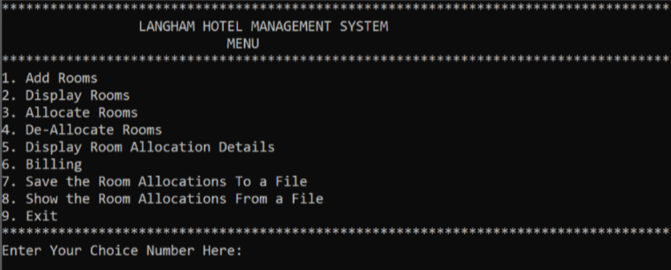
Figure 1: C# based management system
The primary objectives of this system are to:
- Dynamically add and delete hotel rooms.
- Display room specifics and characteristics to enable the customers to make decisions.
- Assign rooms to clients and take bookings.
- Generate bills and check-out.
- Store, plot and save room allocation data by use of file I/O operations.
- Exception handling ensures program robustness and corrects user input errors.
The system uses the built-in Python modules like, datetime, os and json as well as the user-defined functions to achieve modularity.

2. System Overview
The LHMS application is designed with two primary data structures to be able to manage operations of the hotel:
- Rooms List: This is a dynamic array of dictionaries, each dictionary corresponds to a hotel room. The major attributes are room_no, which represents the identifier of the room, type, which is the type of the room (Single, Double, Suite), price that represents the price per night, and features which contains a list of amenities such as AC, TV, or sea view. The list can easily be added and deleted, this ensures that rooms can be well managed in terms of inventory within the hotels.
- Allocations Dictionary: This dictionary is used to match room number to customer allocation record that consists of customer name, number of nights stayed, check-in time and price per night. This system facilitates promptness in the retrieval of booking data, will facilitate the calculation of bills, and will provide a smooth flow of check-ins and check-outs.
The system is menu-driven, but offers understandable options on managing the rooms, allocating customer, billing, and file operations. File I/O functions increase the allocation data persistence and allow creating backup to combat the loss of data (Arora, 2024). Error handling is incorporated in all parts of the application to make sure that bad inputs or any other surprising occurrences would not interfere with running the system, keeping the reliability and a pleasant user experience. As a whole, these design solutions provide a scalable, easy to use and modular solution to hotel management.

3. Pseudocode
START PROGRAM
DISPLAY "Welcome to LANGHAM Hotel Management System"

WHILE True
DISPLAY Main Menu
READ user_choice

IF user_choice == 1 THEN
CALL AddRoom
ELSE IF user_choice == 2 THEN
CALL DeleteRoom
ELSE IF user_choice == 3 THEN
CALL DisplayRooms
ELSE IF user_choice == 4 THEN
CALL AllocateRoom
ELSE IF user_choice == 5 THEN
CALL DisplayAllocations
ELSE IF user_choice == 6 THEN
CALL BillingAndDeallocate
ELSE IF user_choice == 7 THEN
CALL SaveAllocationsToFile
ELSE IF user_choice == 8 THEN
CALL DisplayAllocationsFromFile
ELSE IF user_choice == 9 THEN
CALL BackupAndClearFile
ELSE IF user_choice == 0 THEN
DISPLAY "Exiting application"
BREAK
ELSE
DISPLAY "Invalid choice, enter 0-9"
ENDIF
ENDWHILE

END PROGRAM

FUNCTION AddRoom
READ number_of_rooms
FOR each room
READ room_number, room_type, price, features
ADD room to rooms list
ENDFOR
ENDFUNCTION

FUNCTION DeleteRoom
READ room_number
IF room exists AND not allocated THEN
REMOVE room from rooms list
ELSE
DISPLAY error message
ENDIF
ENDFUNCTION

FUNCTION DisplayRooms
FOR each room in rooms list
DISPLAY room details
ENDFOR
ENDFUNCTION

FUNCTION AllocateRoom
READ room_number
IF room exists AND not allocated THEN
READ customer_name, nights
STORE allocation in allocations dictionary
ELSE
DISPLAY error message
ENDIF
ENDFUNCTION

FUNCTION BillingAndDeallocate
READ room_number
IF room allocated THEN
CALCULATE total bill with tax
DISPLAY invoice
CONFIRM de-allocation
IF confirmed THEN
REMOVE allocation
ENDIF
ENDIF
ENDFUNCTION

FUNCTION SaveAllocationsToFile
OPEN file LHMS_StudentID.txt
WRITE allocation data
CLOSE file
ENDFUNCTION

FUNCTION DisplayAllocationsFromFile
OPEN file LHMS_StudentID.txt
READ and DISPLAY file content
CLOSE file
ENDFUNCTION

FUNCTION BackupAndClearFile
OPEN LHMS_StudentID.txt
COPY content to backup file with timestamp
CLEAR original file
ENDFUNCTION

4. Implementation Details

4.1 Menu Operations
The LANGHAM Hotel Management System (LHMS) is a console based application consisting of a 9-core operations package to manage the operation of hotel rooms and customer bookings. The operations are made in the form of a modular Python function which makes them maintainable and readable.
Add Rooms
It is possible to add a room and choose between one or more rooms by offering unique room number, room type, and price per night and optional features including AC, TV, or Sea View. Data integrity is also ensured by rejecting duplicate room numbers automatically. In the case of the demo run, it was possible to add rooms 11A, 11B, 11C, and 11D which indicates that the system can accept numerous entries and validate them accordingly.
Delete Rooms
It is possible to delete rooms through their room number. The system does not allow any deletion of rooms when a room has been allocated to the client; therefore, it does not interfere with bookings. Trying to delete a room that has not been allocated removes it safely from the records.
Display Room Details
This is whereby it can get a systemized list of all rooms, their types, the price per night, and other features. In the demo, room 11A is represented as a Single room, equipped with AC, TV, and room 11C is represented as a Suite, where the Sea View is available, and which is equipped with AC and TV, and wifi, which proves the appropriate data storage and display formatting.
Room allocation
Customers can get rooms by keying in the room number, customer name, and the number of days to stay. The system makes sure that the room is not located or occupied. Allocation holds the major data including the check-in time and the price per night. An example is that a customer by the name of Olive was booked into room 11A for three nights.
Display Room Allocation Details
The list of allocations is in a formatted table with the following details: room number, customer name, number of nights, rate per night, and the check-in time. This gives a good summary of all the active bookings as illustrated by the single allocation to Olive.
Billing and De-Allocation
The system calculates the total amount which is pre-tax, takes the tax which is 15% and shows the total amount. The users are able to verify checkout to release the room. Exception handling eliminates errors like TypeError or OverflowError, and this aspect makes it easy to bill. Accuracy in financial calculations is also seen in the demo where Olive booking resulted in a bill of 17,940.00 NZD.
Save Room Allocations to a File
Current allocations are saved to a text file (UTF-8 encoded) (LHMS_850006710.txt). The system makes structured header and allocation information to make it readable and durable.
Display Room Allocations File
The system opens and displays the file contents. It is graceful on deletion and empty files making it reliable.
Backup and Clear Allocation File
Backup of allocations is done into a time-stamped file and clearing of the main file is done to avoid loss of data. Indicatively, the backup file written to LHMS_850006710_Backup_20251025_134816.txt and clean up the original file LHMS_850006710.txt.

4.2 File IO Operations
The operations with files are vital in persistence. The context manager of python has a open to close files after reading/writing.
- Saving Allocations: Records organized text which has headers and allocation information (Lund et al., 2023).
- Displaying Allocations: Reads the saved file and displays on the console.
- Backup & Clear: It appends information on a timestamped backup file and clears the initial one.
All the operations that were carried out on the file were made successful in the demo. An example of a backup file is LHMS_850006710_Backup_20251025_134816.txt.

4.3 Exception Handling
Robustness was achieved through try-except blocks to handle foreseen and unforeseen errors:
Exception Type | Implementation
SyntaxError | Demo feature enables one to check expressions in terms of syntax (Deepika, 2025).
ValueError | Handle wrong integer or float inputs of room prices or nights (Deepika, 2025).
ZeroDivisionError | Numerates the numbers without division by zero (Deepika, 2025).
NameError | Top-level checks of undefined modules (like datetime).
TypeError | Checks that arithmetic is not used to mix incompatible types.
OverflowError | Handles very large calculations when billing (Deepika, 20254).
IOError | Uncovers problems in opening files, reading files and writing files (Deepika, 2025).
EOFError | Receives unforeseen end of input by user (Deepika, 2025).
FileNotFoundError | Identifies the absence of allocation files.
With such exception handling methods the system remains graceful in spite of incorrect or unforeseen input.

5. Best Coding Practices and Standards

5.1 Comments
Comments were done in abundance to add clarity to the developers and the maintenance team in the long run (Rani et al., 2021). The functions contained single-line comments describing logic of operations like room allocation, deletion or calculating prices in order to have a clear picture of key steps at the first sight. More complex processes such as billing, de-allocation and file backup were handled using multi-line comments that described the flow of the procedure and how an exception is handled. As an illustration, the billing and deallocate() feature is well documented in computing the stages of the calculation of total charges, calculation of taxes and conditional de-allocation of rooms.

5.2 Identifier Naming
Name conventions of identifiers are descriptive, which favors the code readability and logical mapping. Allocate room, display allocations from file as well as input float are understandable functions that communicate their purposes clearly. Such variables as rooms, allocations, room-no and customer-name were called with the purpose to describe their data storage and processing roles. They were consistent by using underscores (snake_case) instead of CamelCase since it is a standard in Python PEP8 and it allows them to have a consistent codebase (Roberto et al., 2024).

5.3 Python Syntax and Indentation
Indentation and the correct syntax were also heavily followed, which is essential to the block-form Python execution (Python, 2021). Loops, conditionals and exception handling blocks are all indented identically, and thus easier to read. The project uses a uniform spacing of the function calls, operators, and the alignment of the print statements that make the code easily readable especially on the parts of the code that are output intensive like room and allocation displays.

5.4 Function Documentation
Each of the functions has docstrings explaining its purpose, parameters and expected results. As an example, the def add_room includes the document string, which is the definition, """Menu Option 1 - Add new room(s) to the list.""" This type of documentation facilitates fast onboarding of developers and also eases the debugging and subsequent improvements process.

5.5 Version Control
The source code is connected with GitHub that allows to have a version control, to collaborate, and to trace the history of changes. This ensure integrity of the code, enables tracking of issues and enables more than one developer to go on with their work without conflict (Poinet et al., 2020). The essential information, which is room assignments, also has backup, which helps to ensure the safety of operations and reproducibility.

6. Outputs
Adding Rooms:
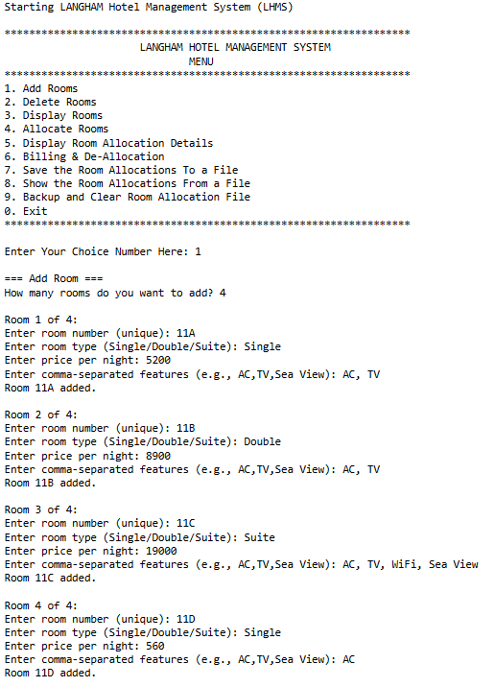
Figure 2: Add Rooms
(Source: Acquired from Jupyter Notebook)
Delete Rooms:
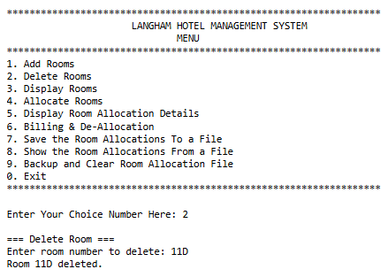
Figure 3: Delete Rooms
(Source: Acquired from Jupyter Notebook)
Allocating Room:
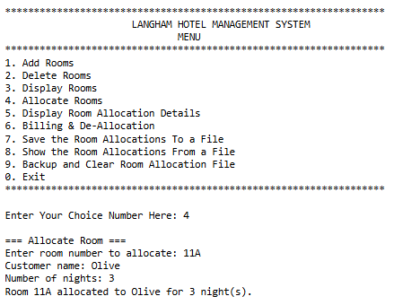
Figure 4: Allocate Rooms
(Source: Acquired from Jupyter Notebook)
Displaying Allocations:
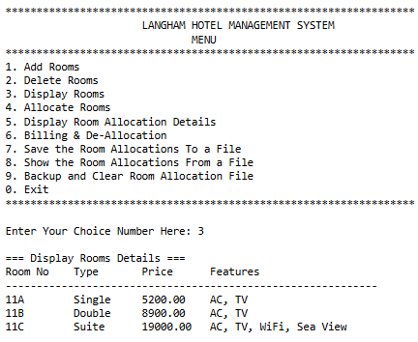
Figure 5: Display Rooms
(Source: Acquired from Jupyter Notebook)
Billing and De-Allocation:
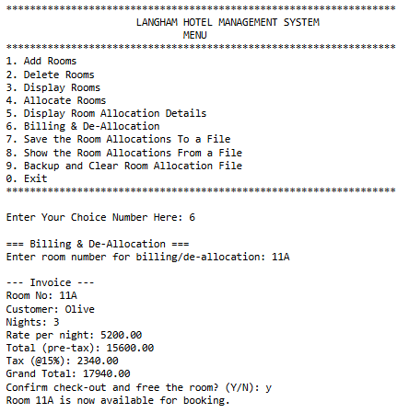
Figure 6: Billing & De-Allocation
(Source: Acquired from Jupyter Notebook)
File Operations:
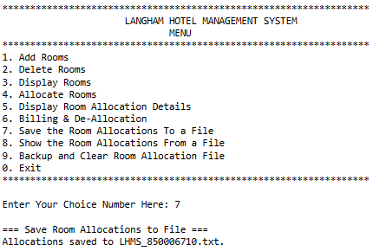
Figure 7: Save the Room Allocations To a File
(Source: Acquired from Jupyter Notebook)
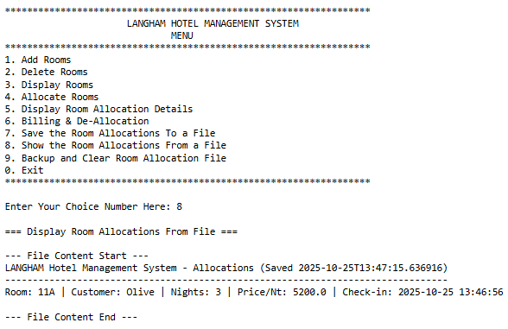
Figure 8: Shows the Room Allocations From a File
(Source: Acquired from Jupyter Notebook)
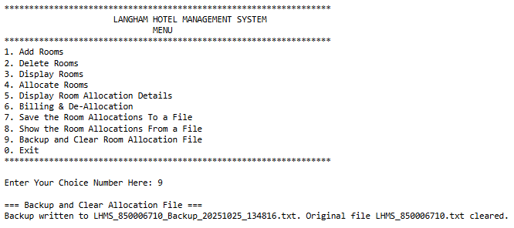
Figure 9: Backup and Clear Room Allocation File
(Source: Acquired from Jupyter Notebook)
Exit Menu:
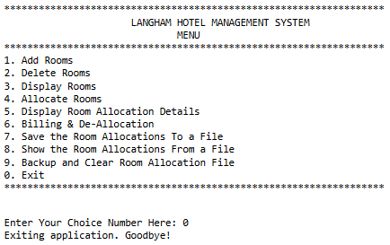
Figure 10: Exit
(Source: Acquired from Jupyter Notebook)

7. Self-Reflection
Python LANGHAM Hotel Management System (LHMS) construction has not only been a gratifying experience in terms of technical, but also on the personal front. During the process, I gradually developed features, paying more attention to reliability, usability, and software engineering best practices. Among the most important ones, there was the introduction of strong input validation which prevented the entry of incorrect room numbers, negative prices, or wrong names format. This greatly minimized the number of runtime interruptions and made the system more acceptable to the user.
Exception handling was the other significant improvement that I did as I handled nine built-in Python exceptions. Primarily, they had crashes that were not expected because of file access problems or wrong data input. The application was now easier to use and more fault tolerant by catching errors such as ValueError, FileNotFoundError, TypeError and OverflowError. This practice sharpened my debugging and improved my knowledge about defensive programming.
I also got to know the modular design significance. Prior to refactoring, there were lengthy and repetitive operations. Proof of this is that by separating each menu service into its own function I was able to increase efficiency of maintenance, decrease complexity and allow reusability and scalability in future, a critical practice in real world software development.
The file IO and data persistence helped me gain practical experience with the file storage, backup, and restoration. Introducing time stamped backups helped me understand the need to protect operational data and plan on the event of business continuity.
The next improvement that was apparent was in User Experience (UX). The establishment of a looping menu and meaningful system also encourages an improved workflow and makes the system easily usable to the non-technicals.
Furthermore, it boost me confidence in a self-independent project development was the fact that now that I was changing the previous incomplete version of C# to a much more stable system in Python. I also got to know how to map business needs into a viable computing solution with the following Python best practices followed, PEP8 naming, documentation, comments, and Github management. This project has enhanced my programming attitude as well as my capacity to deliver to the expectations of the clients.

8. Conclusion
The LANGHAM Hotel Management System effectively fulfills all the assessment and functional specifications that have been established on this project. The system enables the hotel administrators to dynamically add and delete rooms, display rooms and manage them. It also facilitates flawless room distribution to customers, taxation and checkout. Allocation data can be stored, read and backed up safely through structured file I/O facilities, where persistence and data integrity is guaranteed.
High consideration is given to professional code of conduct in the implementation like modularity, good name of identifiers, consistent indent and documentation. The combination of the modules of Python that have been incorporated such as datetime, json, and OS provides functionalities that are practical and that maturity is with regard to the real hotel management needs. Exception management that is associated with dealing with various errors can ensure operational resilience, minimize downtimes, and user satisfaction.
Overall, it is a practical and viable prototype of the system that can potentially be used in the operation of actual hotel processes. The prototypes may be advanced a step further with later extensions which may involve integration of a relational database (such as MySQL), application of the login authentication, application of a GUI interface, the addition of cloud backup and analytics dashboards which will make this prototype a full scale enterprise solution even to a luxury chain of LANGHAM Hotels.
The project was successful by the fact that it not only expressed technical skills but also thoughtful software development approaches, which provides sufficient reasons to proceed and apply it to a practical business environment.

9. References
Arora, I. (2024). Improving performance of data science applications in python. Indian Journal of Science and Technology, 17(24), 2499-2507. https://sciresol.s3.us-east-2.amazonaws.com/IJST/Articles/2024/Issue-24/IJST-2024-914.pdf
Deepika, M. A. (2025). Error Handling in Python. Wordsswiggle publication. https://www.researchgate.net/profile/Deepika-Arumugam-6/publication/393140694_Error_Handling_in_Python/links/6861613c39c35835120564b2/Error-Handling-in-Python.pdf
Lund, B., Agbaji, D., Bissadu, K. D., & Chen, H. (2023). Python for information professionals: How to design practical applications to capitalize on the data explosion. Bloomsbury Publishing USA. https://www.researchgate.net/profile/Brady-Lund/publication/375717571_Python_Programming_for_Information_Professionals_How_to_Design_Practical_Applications_to_Capitalize_on_the_Data_Explosion/links/6571219f286c65604a94743e/Python-Programming-for-Information-Professionals-How-to-Design-Practical-Applications-to-Capitalize-on-the-Data-Explosion.pdf
Poinet, P., Stefanescu, D., & Papadonikolaki, E. (2020, July). Collaborative workflows and version control through open-source and distributed common data environment. In International Conference on Computing in Civil and Building Engineering (pp. 228-247). Cham: Springer International Publishing. https://drive.google.com/file/d/19SOg0YOvBKrQjmNnEq6AzTuTyH1HqKuf/view
Python, W. (2021). Python. Python releases for windows, 24. http://static.softwaresuggest.com.s3.amazonaws.com/ssguides/1604480172_Python_read%20(1).pdf
Rani, P., Abukar, S., Stulova, N., Bergel, A., & Nierstrasz, O. (2021, September). Do comments follow commenting conventions? a case study in java and python. In 2021 IEEE 21st International Working Conference on Source Code Analysis and Manipulation (SCAM) (pp. 165-169). IEEE. https://arxiv.org/pdf/2108.10766
Roberto, P., Gheyi, R., da Costa, J. A. S., & Ribeiro, M. (2024). Assessing Python Style Guides: An Eye-Tracking Study with Novice Developers. arXiv preprint arXiv:2408.14566. https://arxiv.org/pdf/2408.14566

10. Appendix
